GOOGLE CLOUD PLATFORM
Agenda
- Compute Services
- Types of Compute Services
- Overview of Each COmpute Service
- Google Compute Engine
- Virtual Machines
- Storage Services
- Google Cloud Storage
- Filestore in GCP
- Persistent Disk in GCP
- Cloud SQL
- Cloud Spanner
- Bigtable
Compute Services:
Compute services in Google Cloud Platform (GCP) provide the necessary infrastructure to run applications and workloads. These services allow users to deploy, manage, and scale computing resources based on their needs.
Types of Compute Services in GCP:
GCP offers different compute services to cater to various use cases:
- Google Compute Engine (GCE) - Provides virtual machines (VMs) to run applications with full control over the infrastructure.
- Google App Engine (GAE) - A fully managed platform for deploying applications without worrying about server management.
- Google Cloud Functions - A serverless, event-driven execution environment for lightweight applications.
Overview of Each Compute Service:
1. Google Compute Engine (GCE):
- Offers virtual machines (VMs) with customizable configurations.
- Suitable for applications requiring full control over the environment.
- Supports automatic scaling and load balancing.
2. Google App Engine (GAE):
- A Platform-as-a-Service (PaaS) solution for deploying web applications.
- Automatically handles scaling and resource management.
- Supports multiple programming languages such as Python, Java, and Node.js.
3. Google Cloud Functions:
- A serverless compute service that executes code in response to events.
- No need to manage infrastructure; ideal for event-driven applications.
- Supports triggers from HTTP requests, Pub/Sub messages, and Cloud Storage events.
NOTE: We will go with GCE.
Google Compute Engine:
Google Compute Engine (GCE) is an Infrastructure-as-a-Service (IaaS) that provides scalable virtual machines (VMs) to run applications on Google’s cloud infrastructure. It allows users to deploy and manage virtualized resources with high availability, security, and performance.
Key Features of GCE:
- Customizable VMs: Users can choose machine types, CPU, RAM, disk size, and OS based on workload requirements.
- Flexible Pricing: Offers multiple pricing options, including pay-as-you-go, sustained use discounts, and committed use discounts for cost optimization.
- Automatic Scaling: Instances can scale up or down based on real-time demand, optimizing resource usage.
- Preemptible VMs: Cost-effective, short-lived instances designed for batch processing and fault-tolerant workloads.
- Networking and Security: Supports VPC, firewall rules, load balancing, and IAM policies for secure and efficient network connectivity.
- Integration with GCP Services: Seamlessly integrates with Google Cloud services like Cloud Storage, BigQuery, and AI/ML services for enhanced functionality.
Virtual Machine (VM) Instances in GCE:
A VM instance is a virtualized computing resource that runs on Google’s data centers. Users can deploy applications, databases, and services on these instances for various workloads.
Ways to Create a VM Instance in GCE:
VM instances in GCE can be created using:
- Google Cloud Console (Web UI) – Provides a graphical interface to configure and deploy VMs.
- gcloud Command-Line Tool – Allows users to create and manage VMs using CLI commands.
- Terraform (Infrastructure as Code) – Automates VM provisioning and management using code-based configurations.
NOTE: We will create using Web UI.
Steps to Create a VM Using Google Cloud Console:
NOTE: Install the Compute Engine API before creating a VM.
Step 1: Go to GCP Console → Navigate to Compute Engine > VM Instances.
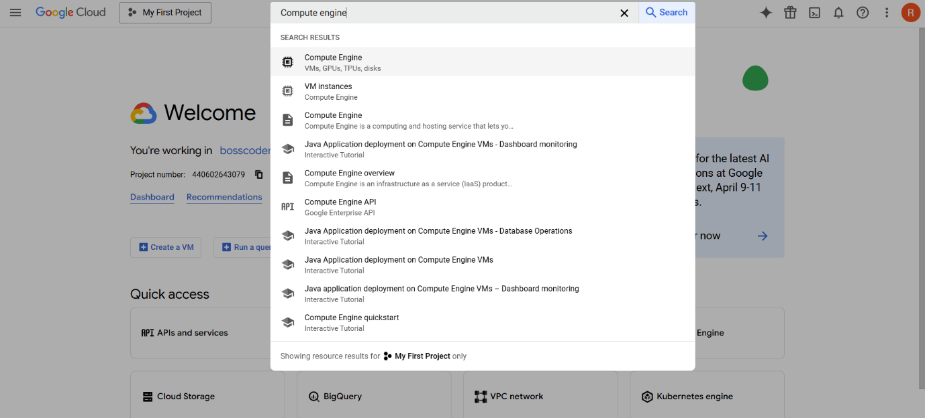
Step 2: Click "Create Instance".
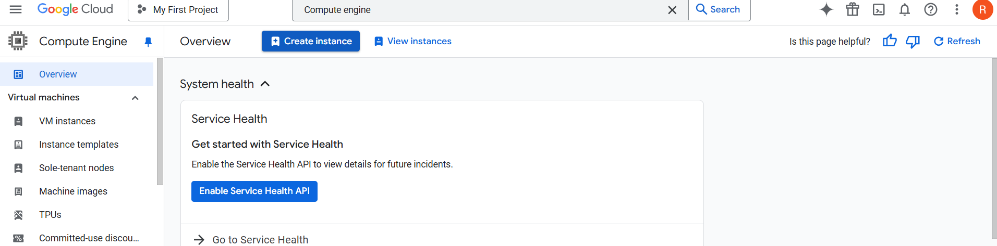

Step 3: Configure the following settings:
- Instance Name: Provide a unique name.
- Region & Zone: Select a geographical location close to your users.
- Machine Type: Choose CPU and memory configurations.
- Boot Disk: Select an OS like Ubuntu, Debian, Windows, or custom images.
- Networking: Configure VPC, firewall rules, and public/private IP addresses.
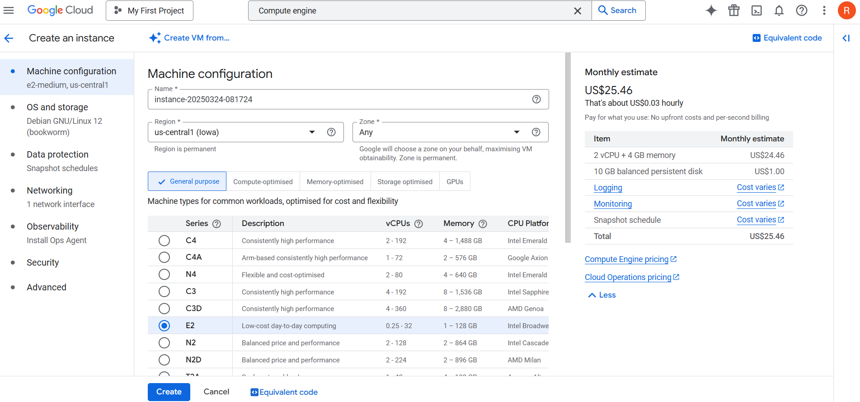
Step 4: Click "Create" to deploy the VM.
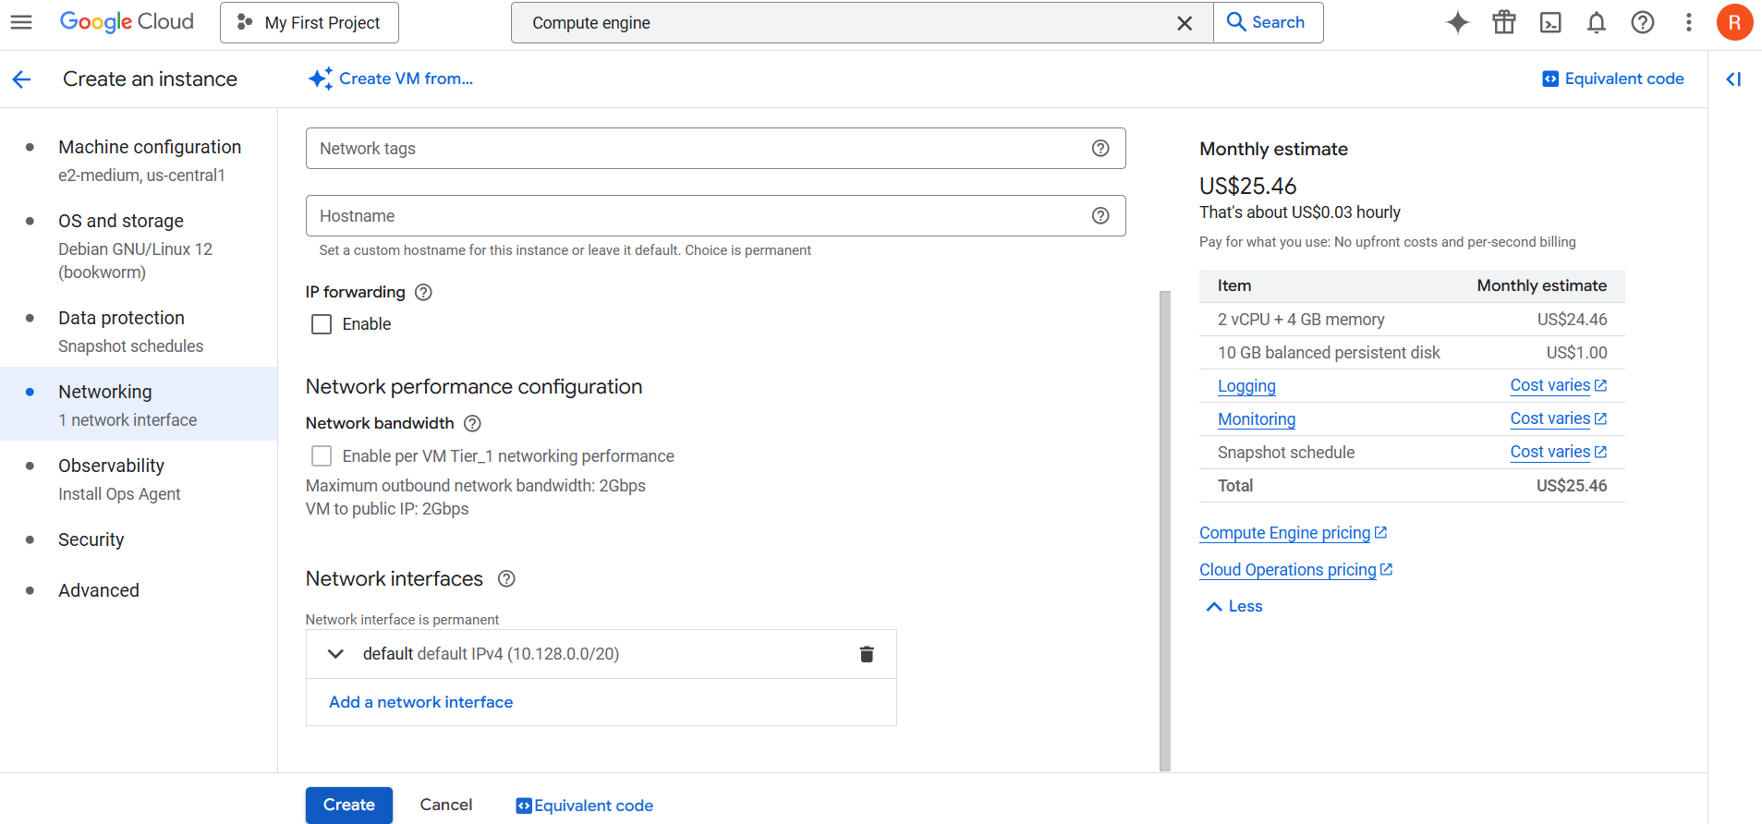
Step 5: Now, you can go to VM instances options, here you will see an option named VM instances, you can click on this option and then you will be able to see the instances that you have created and from the below options you can explore other things also.
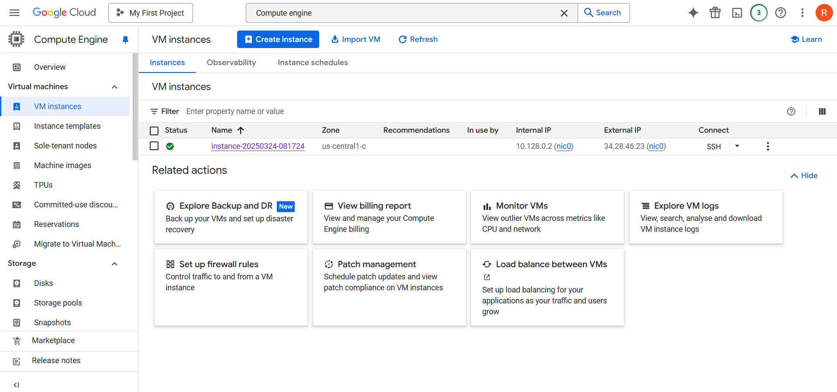
Managing VM Instances:
- Start/Stop a VM: Helps optimize costs when instances are not in use.
- Delete a VM: Removes an instance permanently to free up resources.
- Resize a VM: Upgrade/downgrade CPU, RAM, and disk capacity as needed.
Machine Types in GCE:
Google Compute Engine provides different machine types tailored to various workloads:
- General Purpose Machines: Balanced performance for most workloads (E2, N1, N2, N2D).
- Compute Optimized Machines: High CPU performance for compute-intensive applications (C2, C2D).
- Memory Optimized Machines: Large memory instances for databases and in-memory processing (M1, M2).
- GPU and TPU Machines: Specialized for AI/ML workloads, deep learning, and high-performance computing.
Choosing the Right Machine Type:
- Web Applications: N1-standard-2 (2 vCPUs, 8 GB RAM) is a good choice.
- Big Data Processing: N2-highmem-8 (8 vCPUs, 64 GB RAM) is optimized for large datasets.
- AI/ML Workloads: A100 GPU instances provide high computational power for deep learning.
Storage Options for GCE VMs:
1. Persistent Disks (PD)
Persistent Disks provide durable and scalable storage options:
- Standard PD (HDD): Cost-effective storage for backups and less latency-sensitive workloads.
- SSD PD: High-performance storage optimized for databases and high IOPS applications.
2. Local SSDs
- Super-fast storage directly attached to the VM.
- Ideal for temporary, high-speed caching and read-heavy workloads.
3. Cloud Storage Buckets
- Designed for storing large files and integrating seamlessly with VMs.
- Useful for storing backups, application logs, and multimedia content.
Steps to Attach a Persistent Disk to a VM:
Step 1: Go to Compute Engine → Disks → Create Disks.
Step 2: Select disk type (HDD/SSD), size, and zone.
Step 3: Attach it to an existing VM instance to expand storage capacity.
Networking in GCE:
1. Virtual Private Cloud (VPC):
A Virtual Private Cloud (VPC) allows secure communication between GCP resources. It supports:
- Custom subnets with defined IP ranges.
- VPC Peering for cross-project communication.
- Shared VPC for multi-project connectivity.
2 Firewall Rules:
Firewall rules control traffic flow within GCP instances:
- Allow HTTP/HTTPS Traffic: Enables web applications to be accessible publicly.
- Restrict SSH Access: Ensures secure remote access to VMs by limiting IP ranges.
3. Load Balancing:
Google Cloud Load Balancer distributes incoming traffic efficiently across multiple VMs:
- Global Load Balancing: Routes traffic across different regions.
- Internal Load Balancing: Distributes traffic within a VPC.
Steps to Configure Networking for a VM:
Step 1: Navigate to Compute Engine > VM Instances > Select Instance.
Step 2: Click Edit Network Settings:
- Add or modify public/private IP addresses.
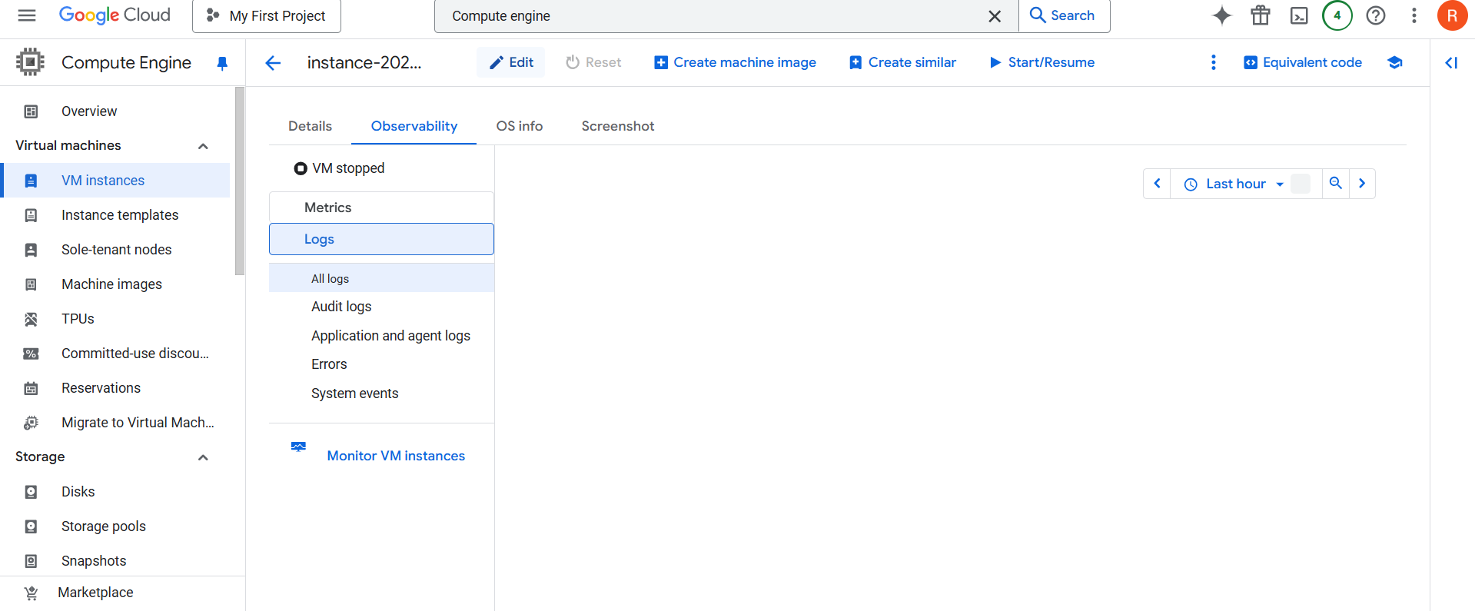
- Configure firewall rules for inbound/outbound traffic.
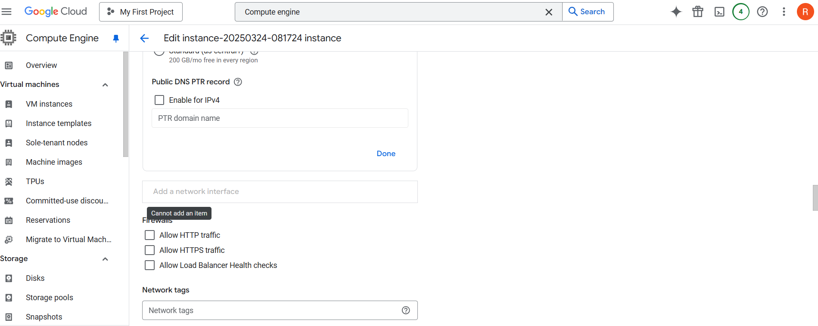
- Attach the VM to a specific VPC network.
Storage Services:
Google Cloud Platform (GCP) provides a range of storage solutions designed to handle different types of data efficiently. Whether structured, semi-structured, or unstructured, GCP storage services offer scalability, security, and high availability. Organizations use GCP storage to store, manage, and process data for various applications, including machine learning, analytics, and web applications.
Cloud Storage:
Cloud storage refers to the online storage of data on remote servers maintained by cloud providers. Instead of storing data on physical devices like hard drives, users can access their files and databases over the internet.
Characteristics of Cloud Storage:
- Scalability: Easily increase or decrease storage as needed.
- Accessibility: Access data from anywhere with an internet connection.
- Durability: Data is replicated across multiple locations to prevent data loss.
- Security: Built-in encryption and access controls to protect data.
Why is Cloud Storage Essential?
- Cost-Effective: No need to invest in physical storage infrastructure.
- High Availability: Access data anytime with minimal downtime.
- Disaster Recovery: Ensures data replication and backup across multiple locations.
- Elasticity: Adjust storage capacity based on demand.
- Global Reach: Store data close to users to improve performance.
Advantages of Using GCP Storage:
- Multi-layered Security: Data encryption at rest and in transit.
- Automatic Backups & Redundancy: Replication across regions for durability.
- Flexible Storage Options: Block storage, object storage, and database storage.
- Pay-as-You-Go Pricing: Pay only for what you use.
- Seamless Integration: Works with other GCP services like BigQuery and AI/ML tools.
Types of Storage Solutions in GCP:
Google Cloud provides different storage options for different use cases.
Storage Type | Description | Best for
Cloud Storage | Object storage for unstructured data. | Backups, media, ML datasets.
Persistent Disk (PD) | Block storage for VMs (like HDDs/SSDs). | Databases, apps with high IOPS.
Filestore | Fully managed file storage (NFS). | Shared storage for applications.
Cloud SQL & Spanner | Managed relational databases. | SQL-based applications.
BigQuery | Serverless data warehouse. | Analytics and reporting.
Google Cloud Storage:
Google Cloud Storage (GCS) is a scalable, durable, and secure object storage service that allows users to store and retrieve any amount of data from anywhere. It is commonly used for backup & recovery, big data analytics, media storage, and machine learning workloads.
Key Features of Google Cloud Storage:
- Multi-Regional Availability – Store data across multiple locations for redundancy.
- Automatic Scaling – Handles any amount of data efficiently.
- Multiple Storage Classes – Optimize cost with different storage tiers.
- Data Lifecycle Management – Automatically move or delete data based on policies.
- Object Versioning – Maintain different versions of files.
- Encryption & Security – Default encryption with customer-controlled options.
- Integration with Other GCP Services – Works seamlessly with BigQuery, AI/ML tools, and Kubernetes.
Storage Classes in GCS:
GCS provides four storage classes, allowing users to optimize cost based on access frequency and storage duration.
Storage Class | Use Case | Access Frequency | Cost
Standard | Frequently accessed data (e.g., websites, apps) | High | High
Nearline | Data accessed < once a month (e.g., backups) | Medium | Lower
Coldline | Data accessed < once a year (e.g., archives) | Low | Lower
Archive | Long-term storage (e.g., regulatory data) | Very Low | Lowest
Creating a GCS Bucket with Different Storage Classes:
Step 1: Open Google Cloud Console → Go to Cloud Storage.
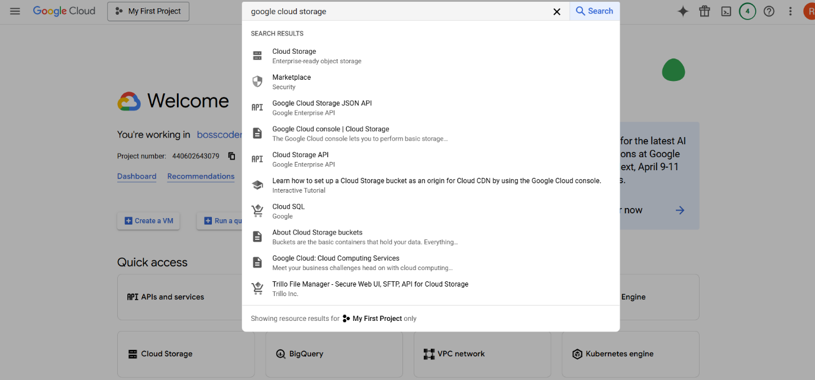
Step 2: Click Create Bucket → Enter a unique bucket name.
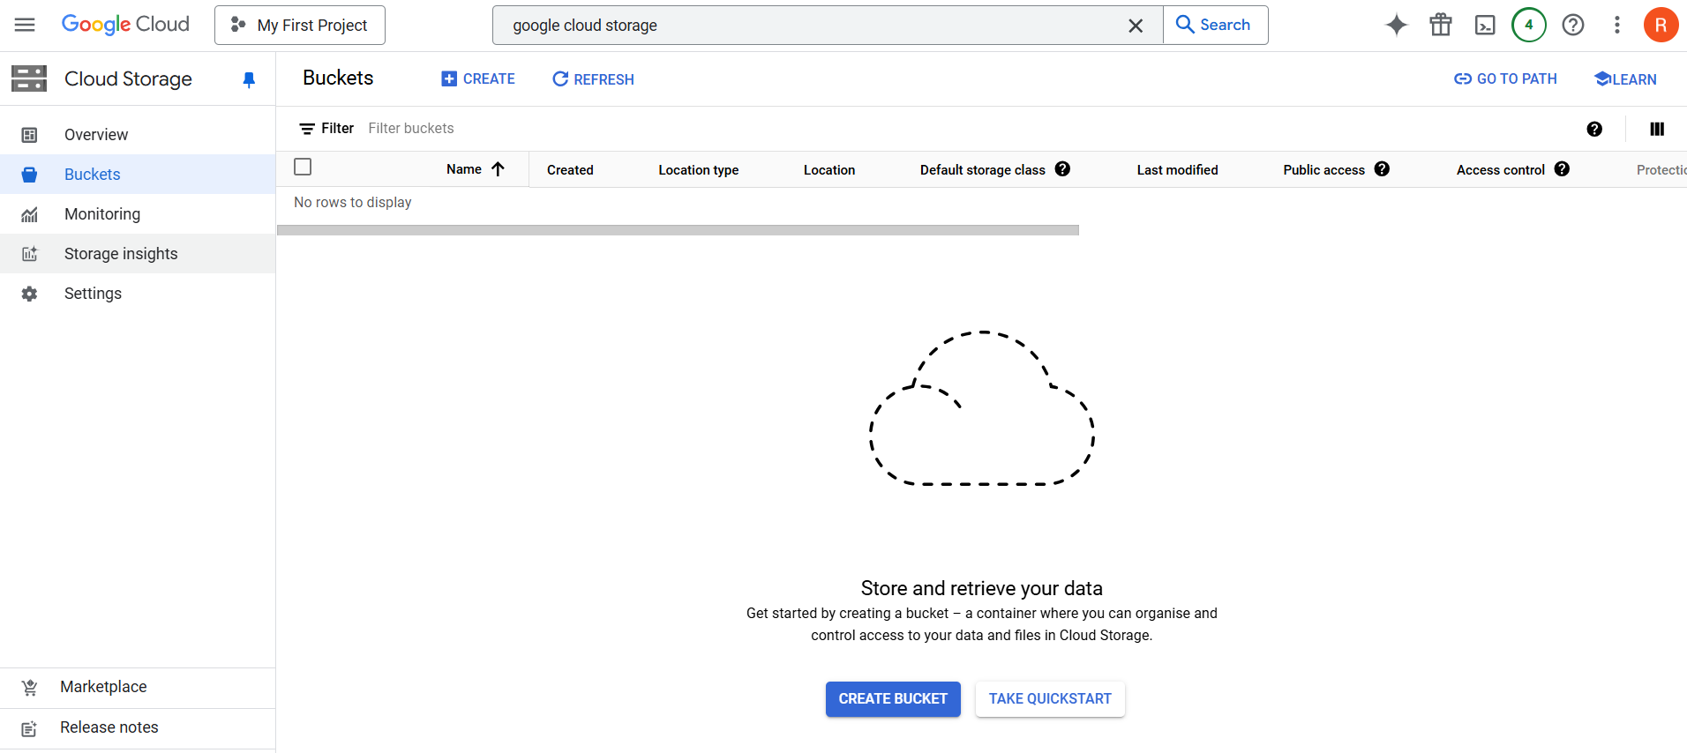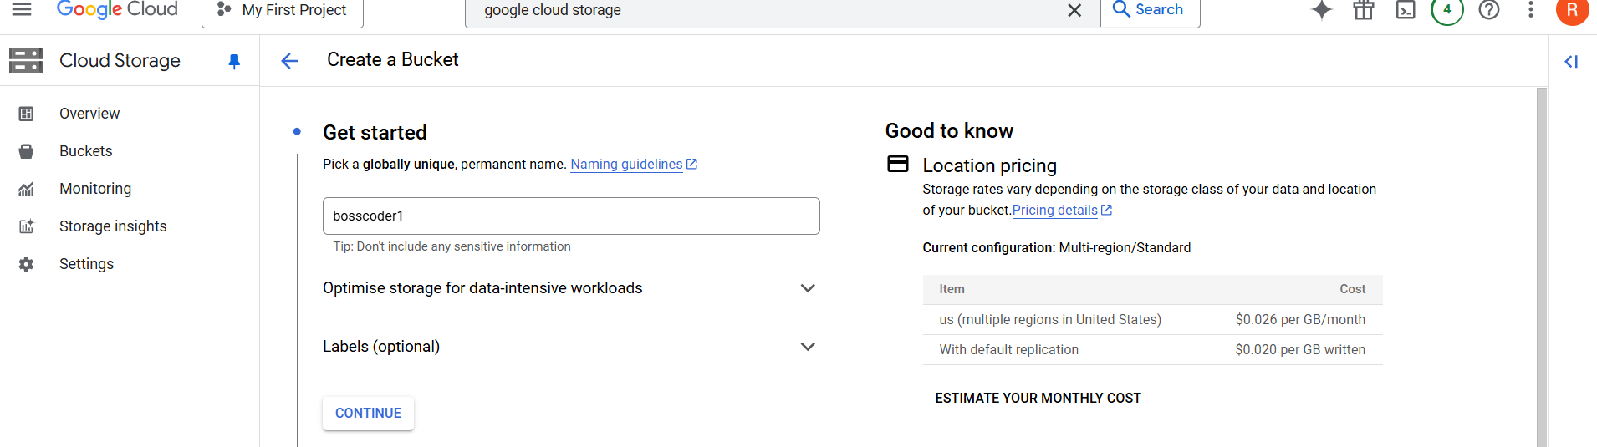
Step 3: Choose Storage Class (Standard, Nearline, Coldline, or Archive).
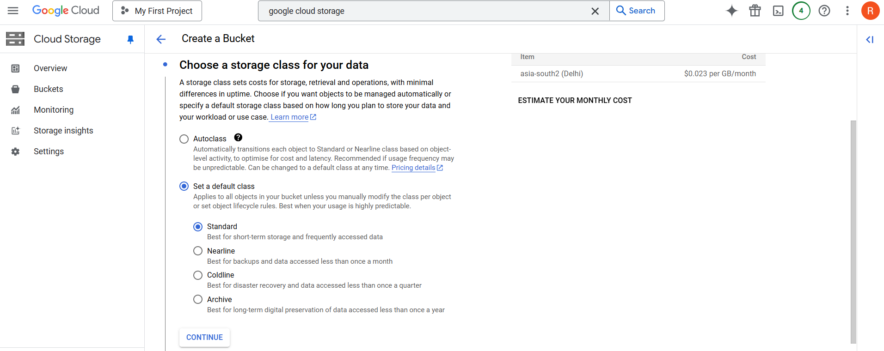
Step 4: Select a Region (multi-region or single region).
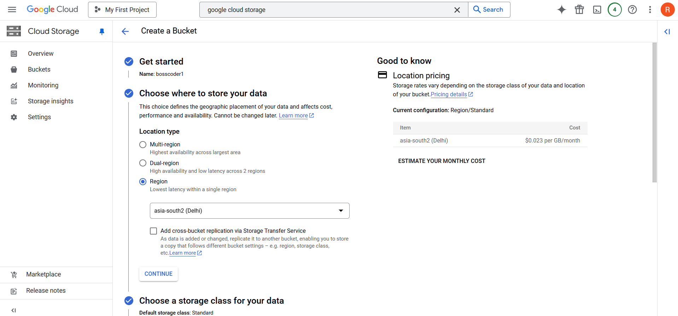
Step 5: Click Create.
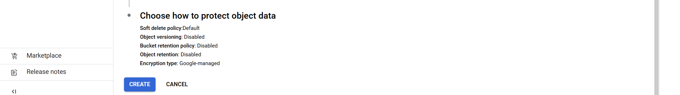
Data Lifecycle Management in GCS:
Lifecycle rules help manage storage costs by automatically transitioning or deleting objects based on conditions.
Common Use Cases:
- Move objects from Standard to Coldline after 30 days.
- Delete objects older than 365 days automatically.
- Delete noncurrent versions of objects.
Creating a Lifecycle Rule in GCS:
Step 1: Go to your GCS Bucket → Click Lifecycle tab.Step 2: Click Add a Rule → Select Condition (e.g., age > 30 days).Step 3: Choose Action (Delete, Change Storage Class).Step 4: Click Create Rule.
Object Versioning in GCS:
Object versioning helps preserve, retrieve, and restore older versions of objects.
Key Benefits:
- Prevent accidental data loss.
- Restore an earlier version of a file if needed.
- Each version has a unique generation number.
Enabling Object Versioning & Restore a Deleted File:
Step 1: Navigate to your Bucket → Click Edit Settings.Step 2: Enable Object Versioning.Step 3: Upload a file multiple times with the same name.Step 4: Delete the file → Restore an earlier version.
Encryption in GCS:
Google Cloud automatically encrypts data at rest and in transit. Users can choose three encryption options:
Encryption Type | Description
Default Encryption | GCP manages encryption keys automatically.
Customer-Managed Keys (CMEK) | Users create & manage keys in Cloud KMS.
Customer-Supplied Keys (CSEK) | Users provide their own encryption keys.
Using Customer-Managed Encryption Keys (CMEK):
Step 1: Create a Cloud KMS Key Ring.Step 2: Create a Cryptographic Key under the key ring.Step 3: Enable Customer-Managed Encryption in GCS when creating a bucket.
Filestore in GCP:
Filestore is a fully managed Network File System (NFS) service in Google Cloud that provides low-latency, high-throughput file storage for applications that require shared access.
Unlike Cloud Storage (Object Storage), Filestore is designed for workloads that require POSIX-compliant, file-based access, such as web applications, content management systems, and data analytics.
Key Features:
- Managed NFS Storage – Supports NFS v3 & v4, making it easy to integrate with Linux-based applications.
- High Performance & Low Latency – Designed for high-throughput workloads.
- Automatic Scaling – Scales up to petabytes as needed.
- Multiple Service Tiers – Choose performance and cost based on workload requirements.
- Seamless Integration – Works with Compute Engine, GKE, and AI/ML tools.
Difference Between Object Storage & File Storage:
Feature | Object Storage (Cloud Storage) | File Storage (Filestore)
Access Type | HTTP API | POSIX/NFS (mountable)
Best For | Unstructured data, backups | Shared file access, applications
Latency | High (not optimized for speed) | Low (high performance)
Scalability | Virtually unlimited | Scalable up to petabytes
Use Cases | Backup, data lake, logs | Shared workloads, apps, HPC
Setting-up Google Cloud Filestore:
Step 1: Go to Google Cloud Console (https://console.cloud.google.com), click on the Navigation Menu (☰), select Storage → Filestore, and click "Create Instance".
Step 2: Enter an Instance Name, select the Region & Zone (same as your Compute Engine VM), choose the Service Tier (Basic, Enterprise, or High Scale), and set the Storage Capacity (minimum 1 TB for Basic, 2.5 TB for Enterprise). Under Network Settings, select the same VPC as your VM, then click Create.
Step 3: Go to Navigation Menu (☰) → VPC Network → Firewall, click Create Firewall Rule, set the Name (e.g., allow-nfs), select Target as "All instances in the network," and enter Source IP Ranges as 0.0.0.0/0 (or restrict to your VPC). Enable TCP Port 2049 (NFS) and click Create.
Step 4: Go to Storage → Filestore, click on your Filestore instance, and copy the NFS IP Address (e.g., 10.0.0.5).
Step 5: Attach Filestore to Compute Engine VM
Go to Compute Engine → VM Instances, click on your VM instance, open SSH, and follow the Mount Instructions provided in the Filestore UI.
Step 6: Enable Auto-Mount (Optional)
In Compute Engine → VM Instances, click on your VM → Edit, scroll to Custom Metadata, add a new entry with Key as startup-script and Value as the mount command from Filestore UI, then click Save.
Persistent Disk (Block Storage) in Google Cloud Platform (GCP):
Introduction:
- Block storage is a storage architecture where data is divided into blocks and stored separately.
- Each block has a unique identifier, allowing fast read/write operations.
- Block storage is commonly used for operating system disks, databases, and high-performance applications.
- In GCP, Persistent Disk (PD) is the primary block storage service used with Compute Engine VMs.
Persistent Disk Types in GCP:
Google Cloud provides different types of Persistent Disks optimized for various workloads:
a. Standard Persistent Disks (pd-standard)
- HDD (Hard Disk Drive)-based storage.
- Suitable for low-cost, sequential workloads such as backups, log storage, and archiving.
- Higher latency compared to SSD.
b. Balanced Persistent Disks (pd-balanced)
- Offers a balance between cost and performance.
- Ideal for web applications, medium-scale databases, and general-purpose workloads.
c. SSD Persistent Disks (pd-ssd)
- SSD (Solid State Drive)-based storage with low latency and high IOPS.
- Best for transactional databases, analytics workloads, and high-performance applications.
d. Extreme Persistent Disks (pd-extreme)
- Designed for ultra-high-performance workloads.
- Provides up to 120,000 IOPS per disk.
- Best for enterprise applications requiring very high throughput.
Snapshots and Backups:
- Snapshots are used to create backups of Persistent Disks.
- Snapshots are incremental, meaning only changed data is stored.
- They help in disaster recovery, backup strategies, and migrating workloads.
Encryption and Security:
- All Persistent Disks are encrypted by default using Google-managed encryption keys.
- Users can choose Customer-Managed Encryption Keys (CMEK) for added control.
- Data is encrypted using AES-256 encryption for security.
Creating and Attaching a Persistent Disk to a VM:
Step 1: Create a Persistent Disk
- Open the Google Cloud Console: Compute Engine -> Disks.
- Click on "Create Disk".
- Fill in the required details:
  - Name: Enter a unique name for the disk.
  - Region & Zone: Select the same zone as your VM for better performance.
  - Disk Type: Choose between Standard HDD, SSD, or Balanced Persistent Disk.
  - Size: Define the required storage capacity (e.g., 100GB).
- Click "Create" to finalize the disk creation.
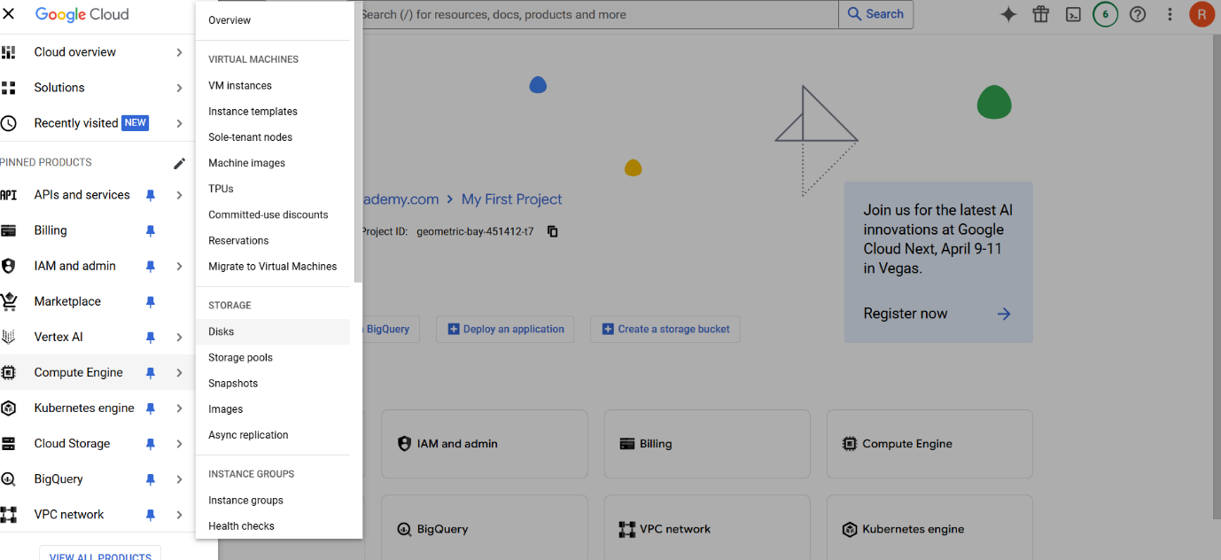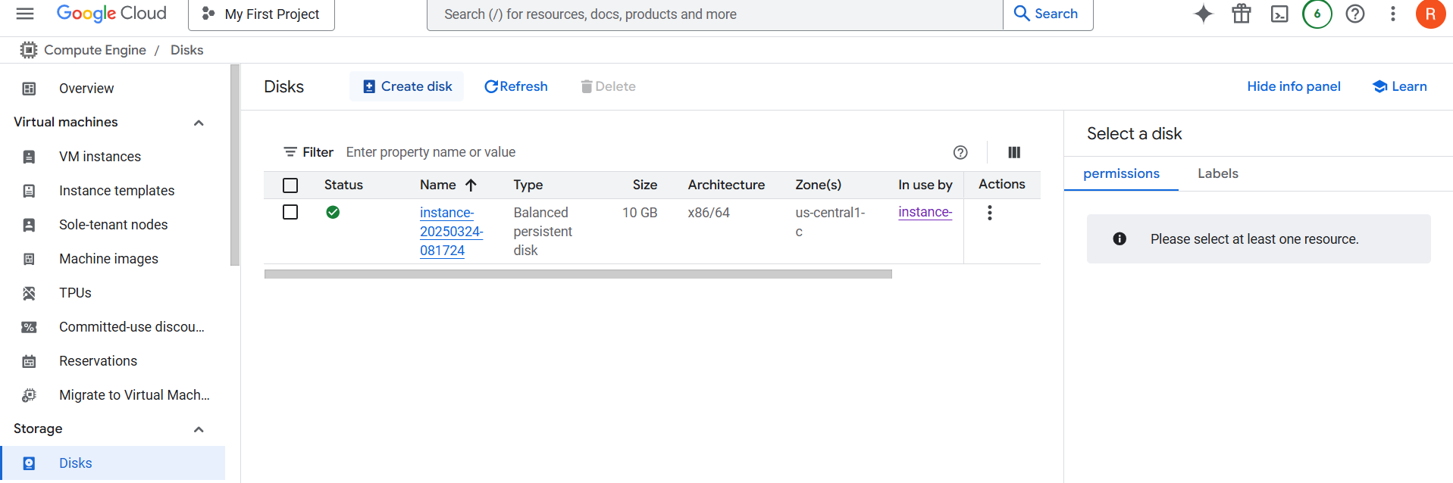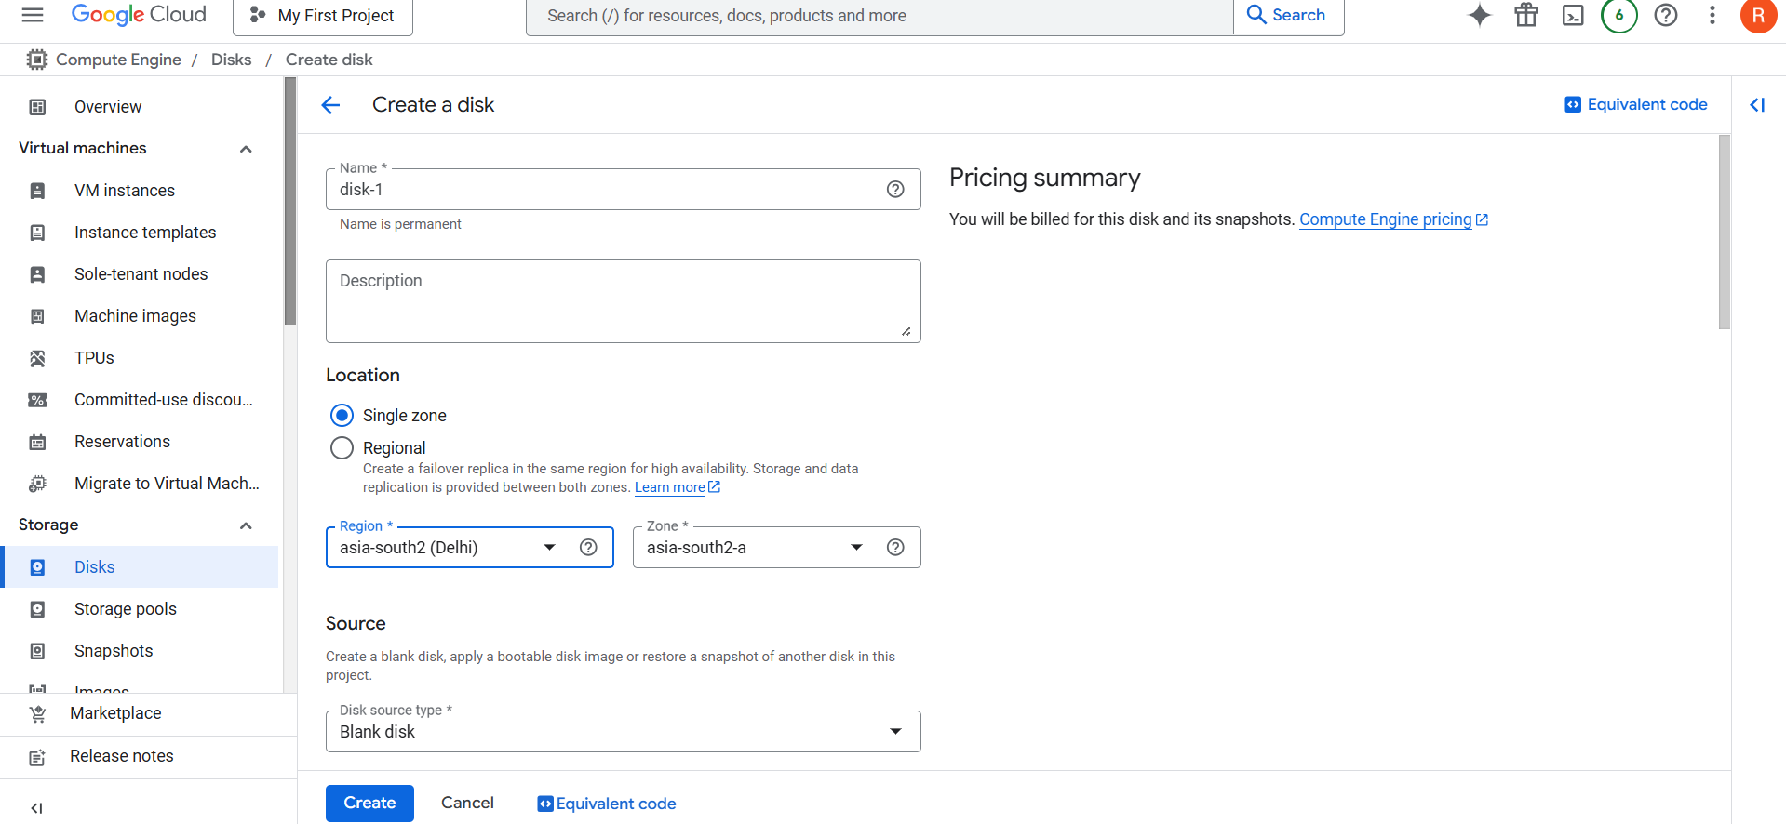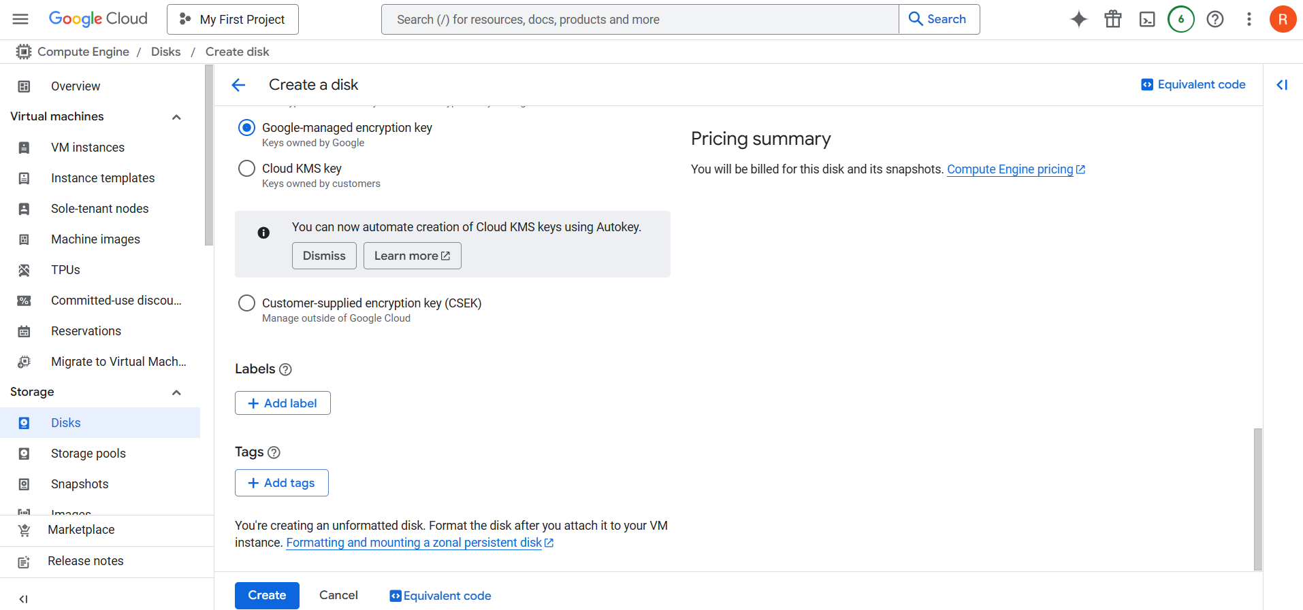
Step 2: Attach the Disk to a VM
- Go to Compute Engine → VM instances in the Google Cloud Console.
- Click on the VM instance where you want to attach the disk.
- Click Edit at the top of the page.
- Scroll to the "Additional Disks" section.
- Click "Attach existing disk" and select the disk you created.
- Click "Save" and then restart the VM if required.
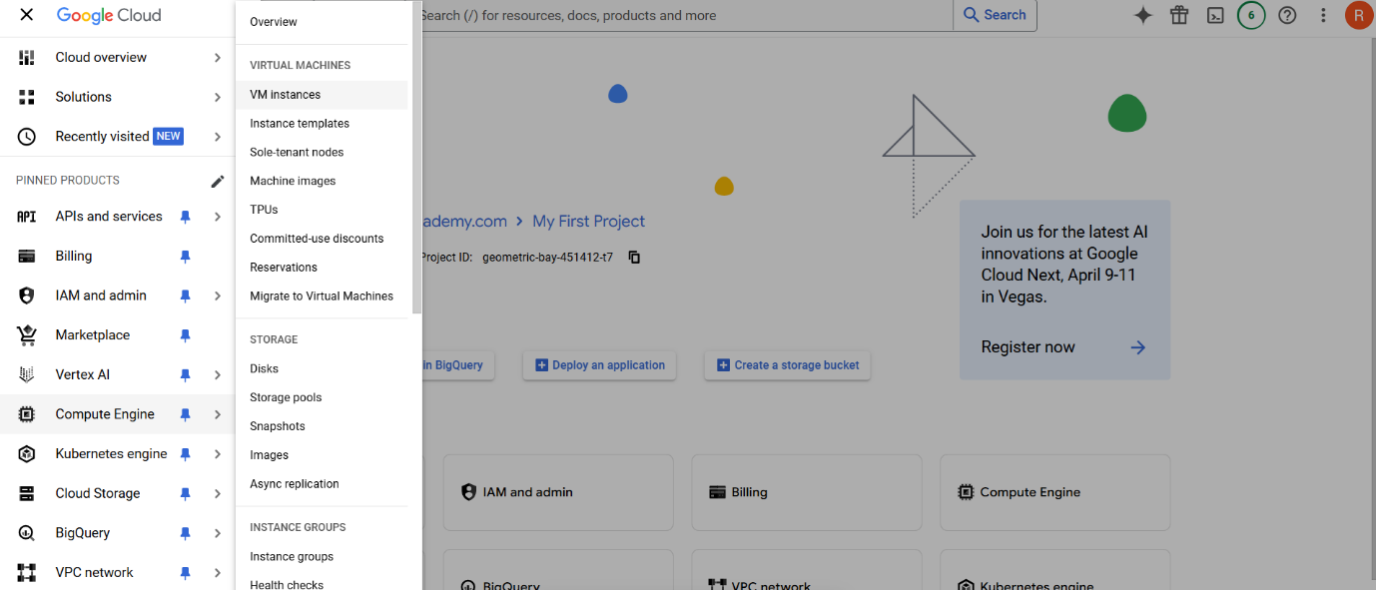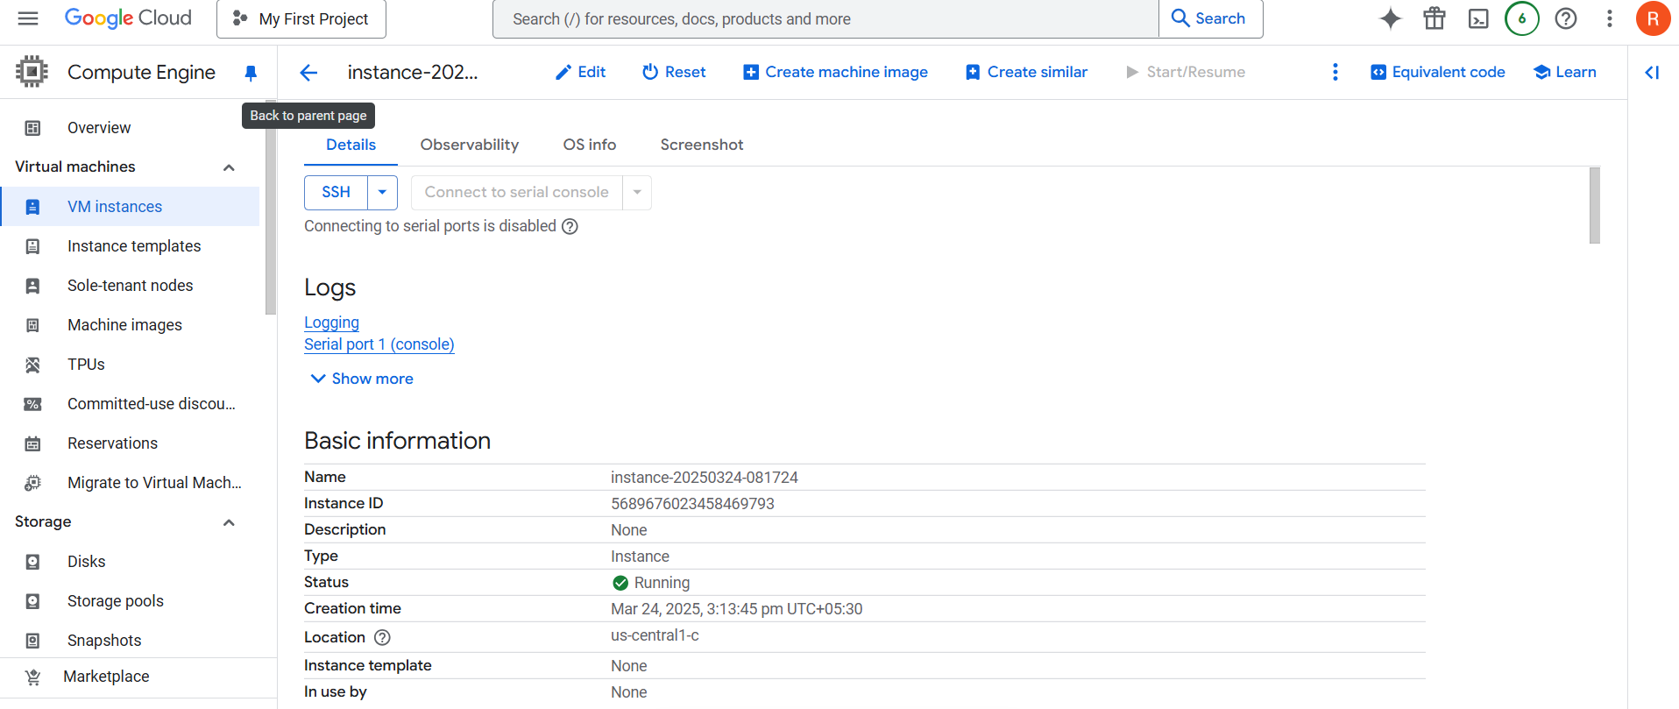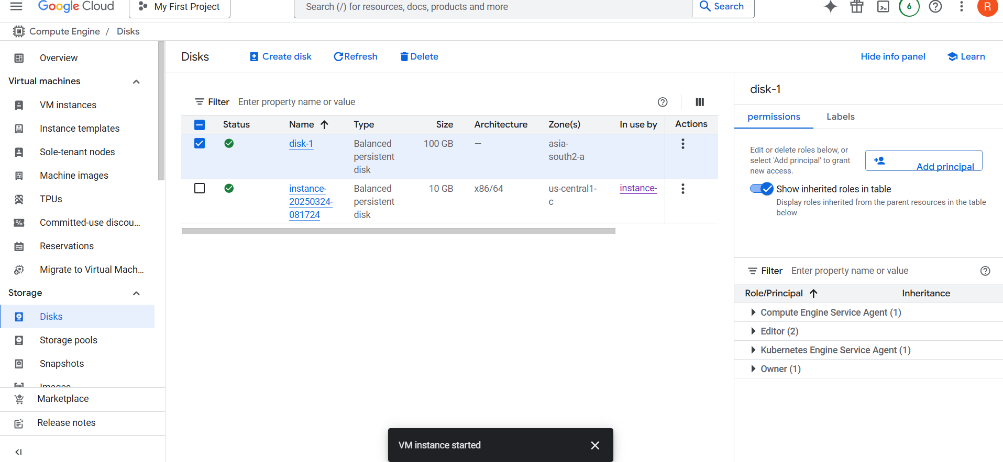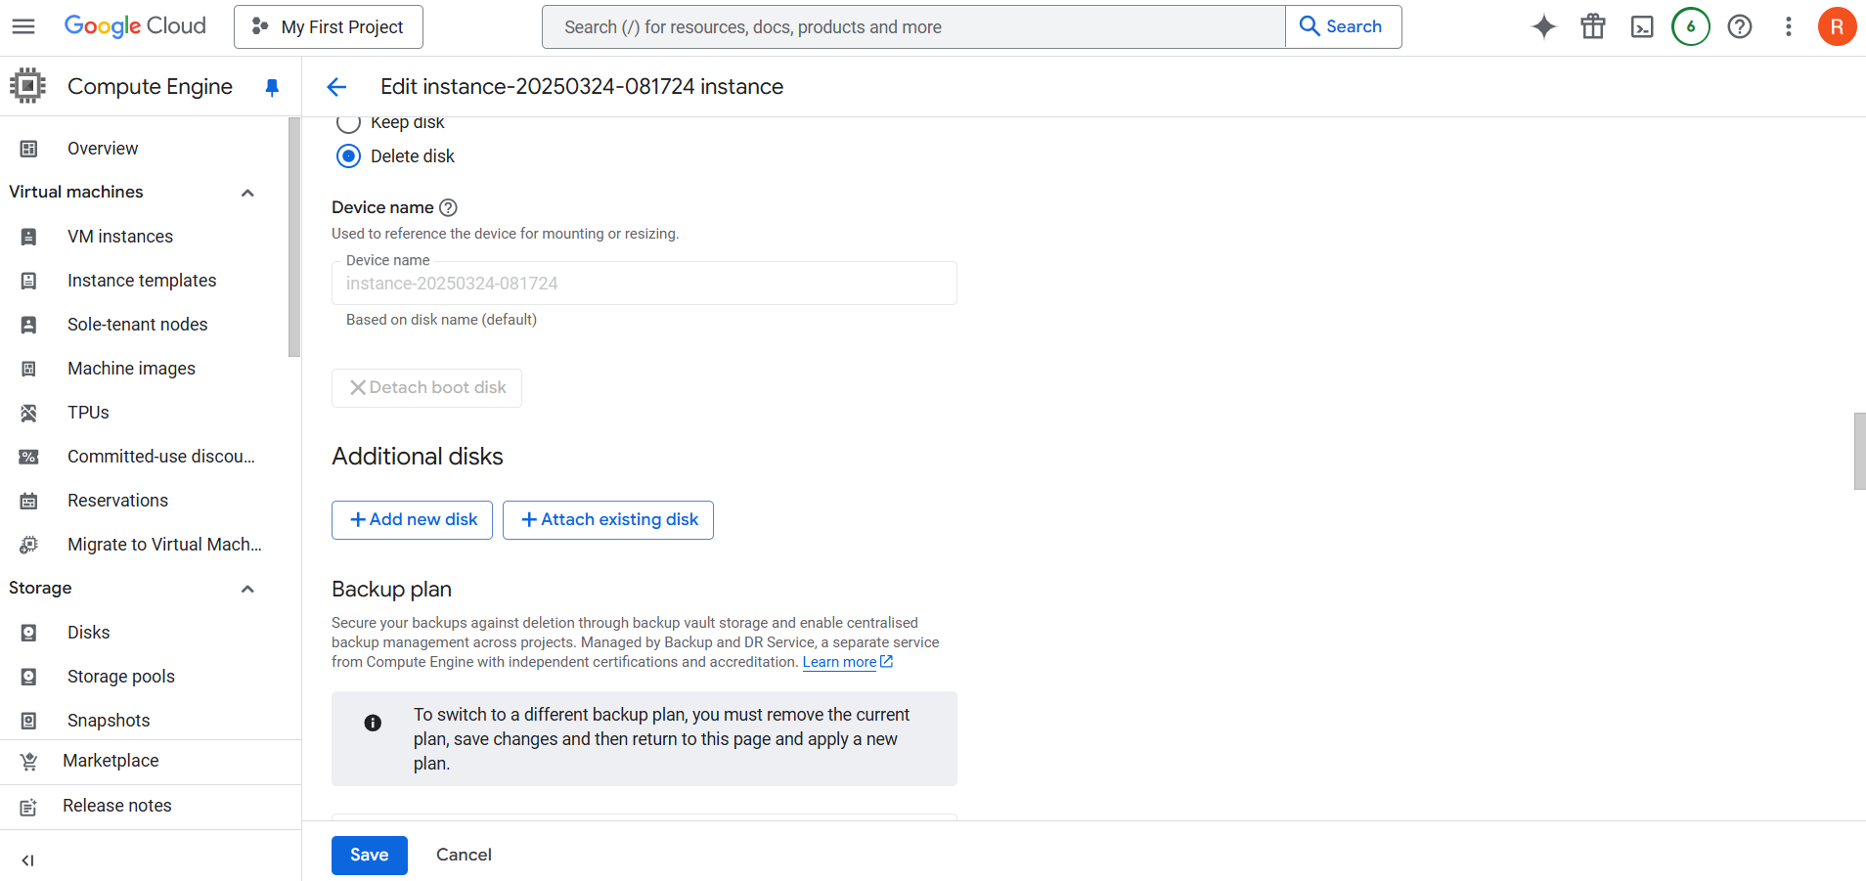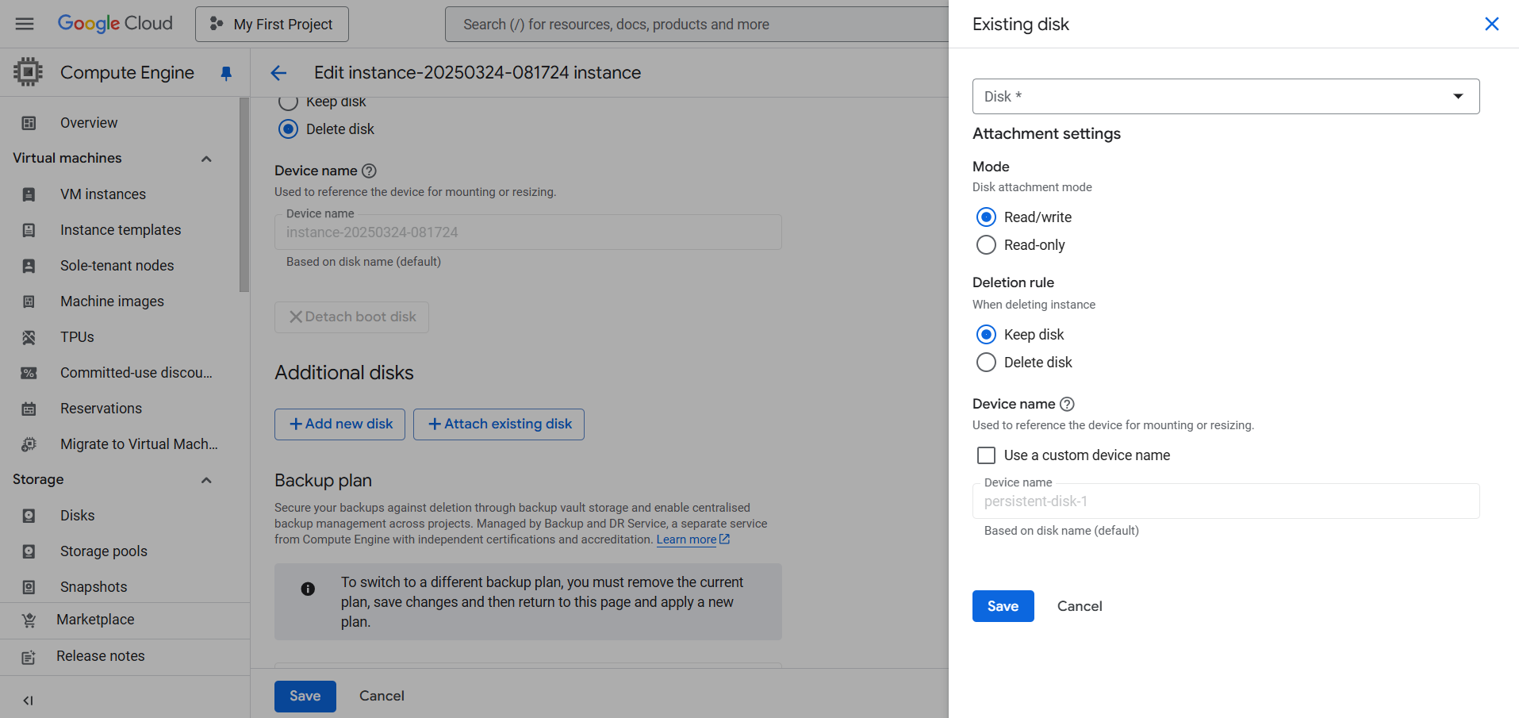
Step 3: Format and Mount the Disk:
- Go to Compute Engine → VM Instances.
- Click on the instance where the disk is attached.
- Click on the "SSH" button to connect to the VM.
- Inside the SSH terminal, follow the on-screen instructions to initialize the disk.
- Once formatted, you can mount it via the Google Cloud Console in the Disks section.
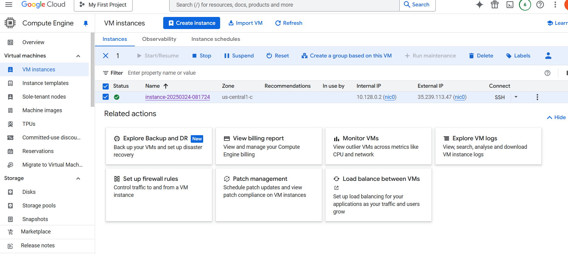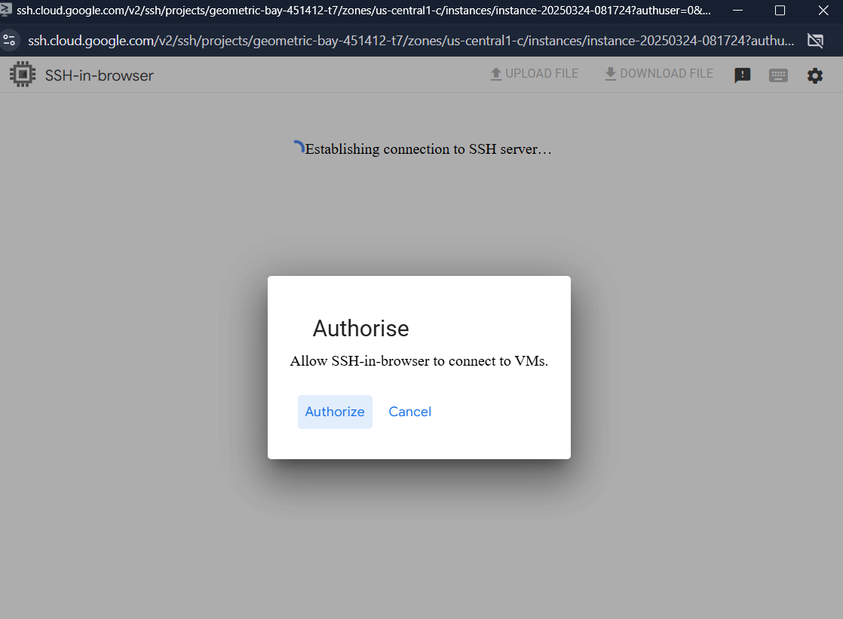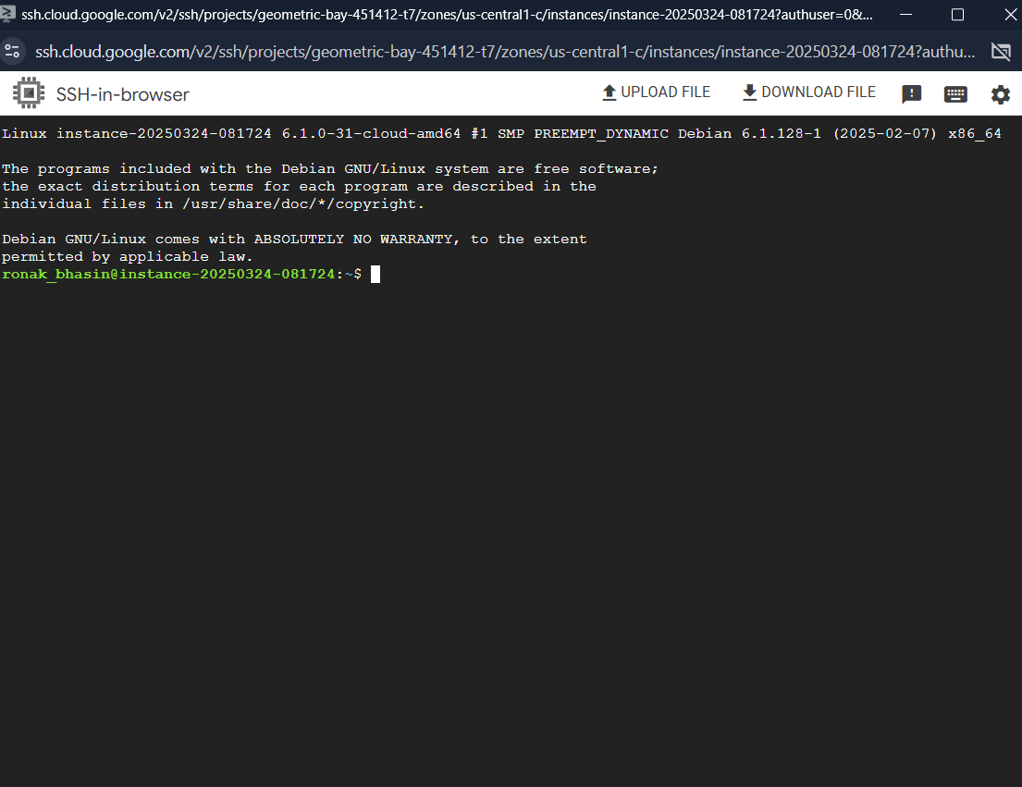
Step 4: Resize a Persistent Disk:
- Open Compute Engine → Disks.
- Click on the disk you want to resize.
- Click "Edit" at the top.
- Increase the disk Size as needed.
- Click "Save" to apply changes.
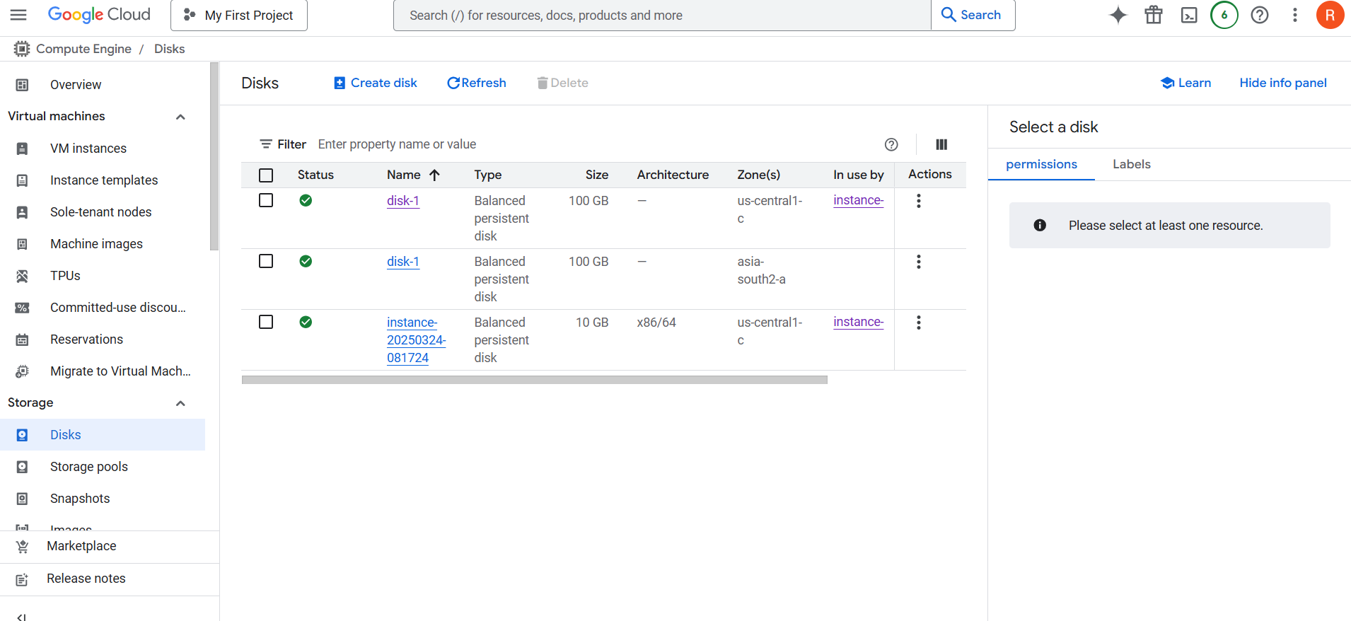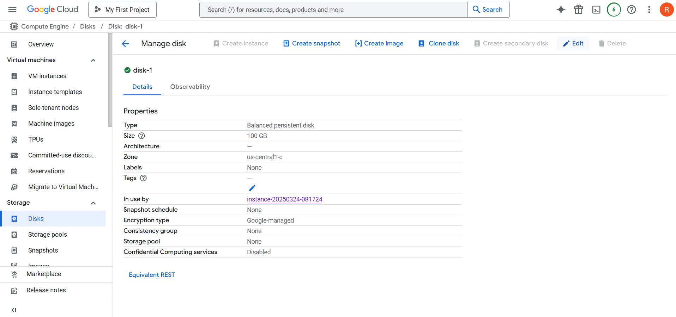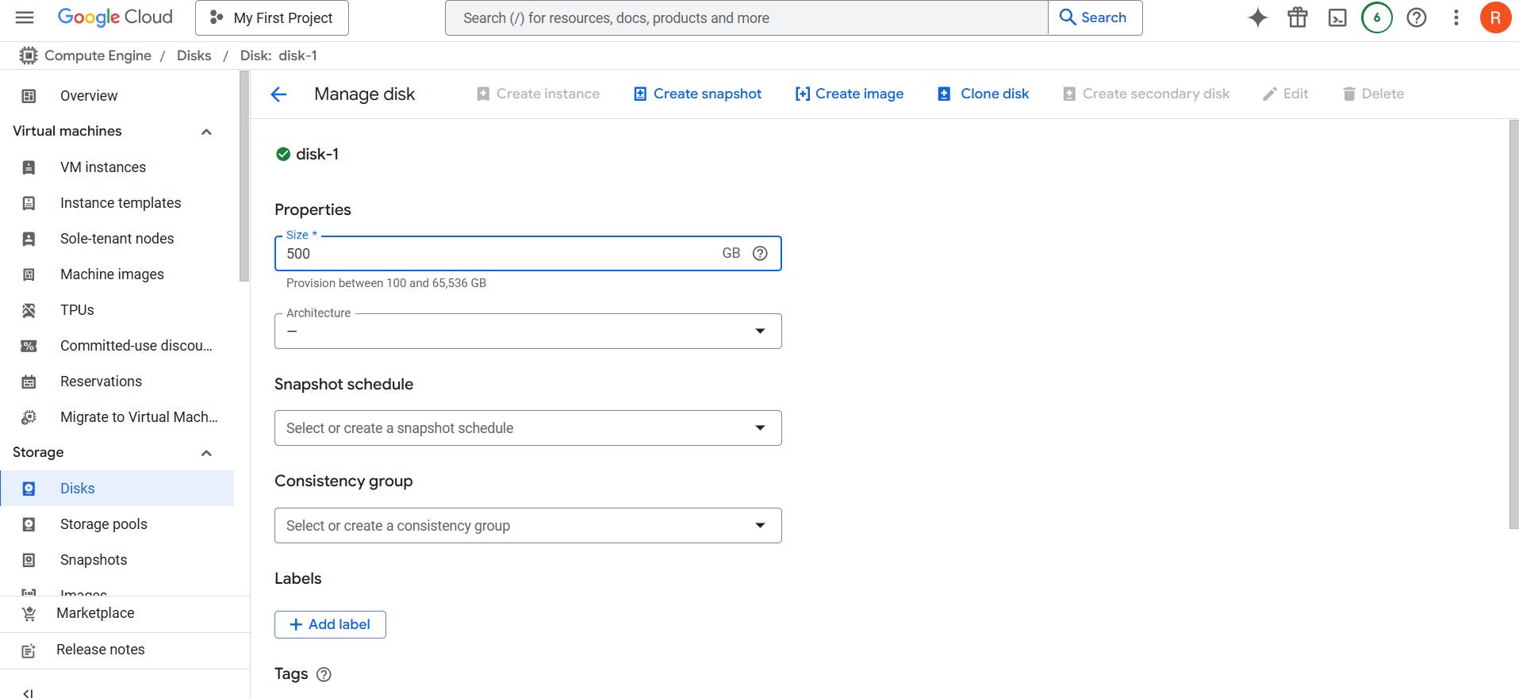
Step 5: Detach or Delete a Disk (If Needed):
- Detach a Disk:
  - Stop the VM instance first.
  - Go to Compute Engine → Disks.
  - Click on the disk → Click Detach.
- Delete a Disk:
  - Go to Compute Engine → Disks.
  - Click on the disk → Click Delete (this action is irreversible).
Cloud SQL: Fully Managed Relational Database Service:
Cloud SQL is a fully managed relational database service provided by Google Cloud, supporting MySQL, PostgreSQL, and SQL Server. It is designed to eliminate database maintenance overhead while offering high availability, automated backups, and scalability.
Key Features:
- Automated Management: Handles patches, updates, and maintenance.
- Scalability: Supports read replicas and vertical scaling.
- Security: Integrated IAM authentication and encryption.
- Backup & Disaster Recovery: Automated daily backups and point-in-time recovery.
- Connectivity: Supports private and public IP, VPC peering, and Cloud Interconnect.
Use Cases:
- Applications requiring ACID compliance.
- Traditional OLTP (Online Transaction Processing) workloads.
- Hosting existing MySQL, PostgreSQL, or SQL Server databases on the cloud.
Cloud Spanner: Distributed & Scalable Relational Database
Cloud Spanner is a unique relational database offering horizontal scalability while maintaining strong consistency and ACID transactions. It is Google’s answer to global-scale relational workloads that demand high performance and reliability.
Key Features:
- Global Scalability: Supports distributed transactions across multiple regions.
- Strong Consistency: Ensures data consistency across all replicas using TrueTime API.
- Automatic Sharding: Dynamically distributes data across nodes.
- Multi-Region Availability: Built-in replication for high availability.
- SQL Querying with Schema: Uses Spanner Query Language (SQL-based).
Use Cases:
- Applications needing global consistency and high availability.
- Large-scale financial transactions and supply chain systems.
- Gaming leaderboards and user profile databases that require low-latency reads/writes.
Bigtable: NoSQL Database for Large Workloads:
Cloud Bigtable is Google Cloud’s fully managed NoSQL database optimized for high-throughput, low-latency workloads. It is best suited for time-series, IoT, and analytical workloads where scalability and performance matter.
Key Features:
- Wide-Column Store: Uses HBase API for schema design flexibility.
- Extreme Scalability: Supports petabyte-scale workloads.
- Low Latency: Ideal for real-time analytics.
- Seamless Integration: Works with BigQuery, Dataflow, and AI/ML models.
- Automatic Scaling: Adds or removes nodes based on demand.
Use Cases:
- Time-series data (stock market, IoT sensor logs).
- Recommendation engines (personalized content).
- Ad-tech and fraud detection (handling billions of events).
- Operational analytics for large-scale datasets.

